# Durable Furnitures

Alfonso

## Forged Leaves and Glass Table Lamp

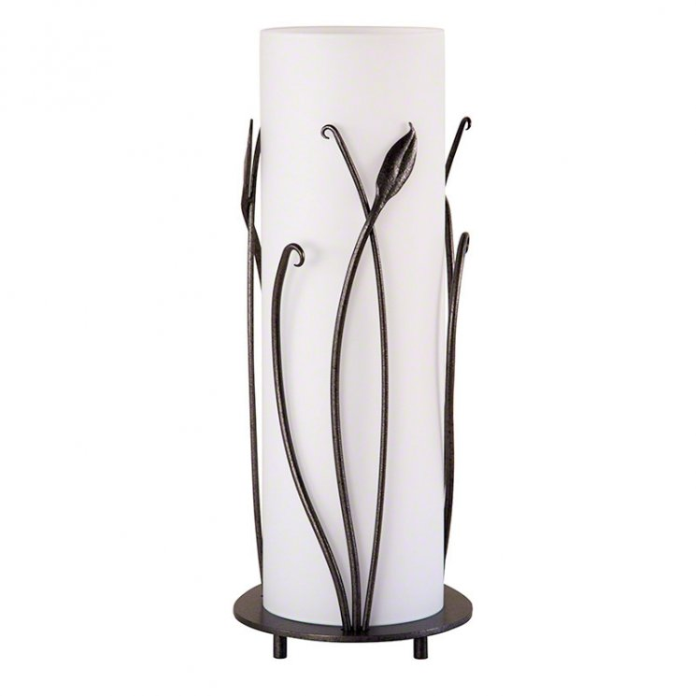

Looking for that unique table lamp that stands out from the rest? Well, look no further than our Hubbardton Forge hand-made Forged Leaves with Glass Table Lamp. A beautiful organic leaf design hand-forged in wrought iron are further enhanced by its soft warm glow from your choice of translucent glass and metal finish. Great for any room of your home.